Deploy / Delete Teamcity docker

# **Install and Deploy Teamcity docker**

1. Click “Deploy” button on “ln02-9ci-com: application” workload page

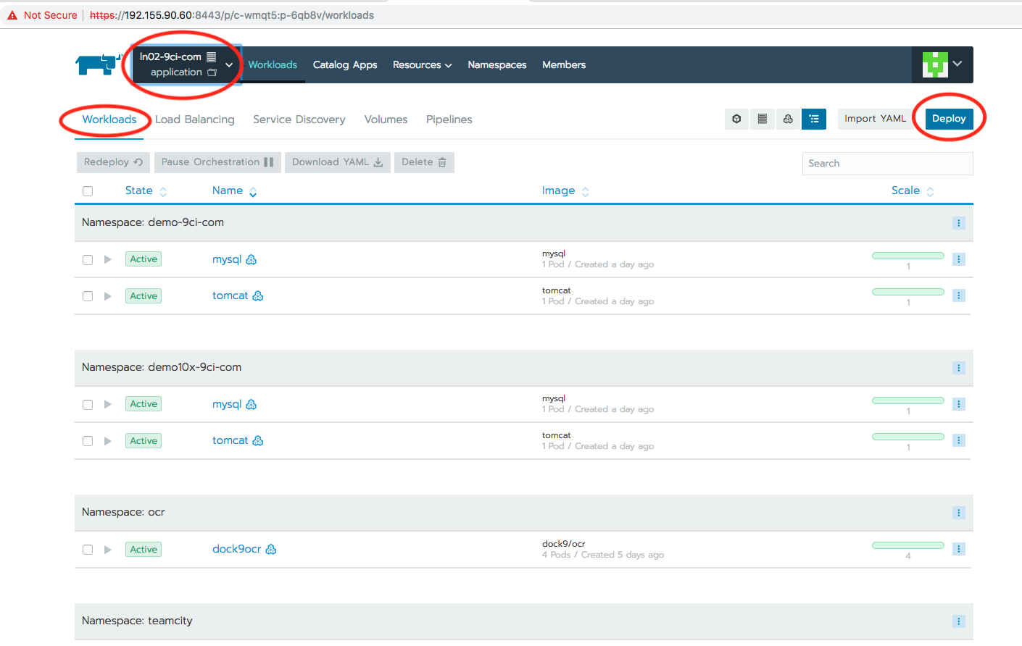

1. Enter field values as following as:

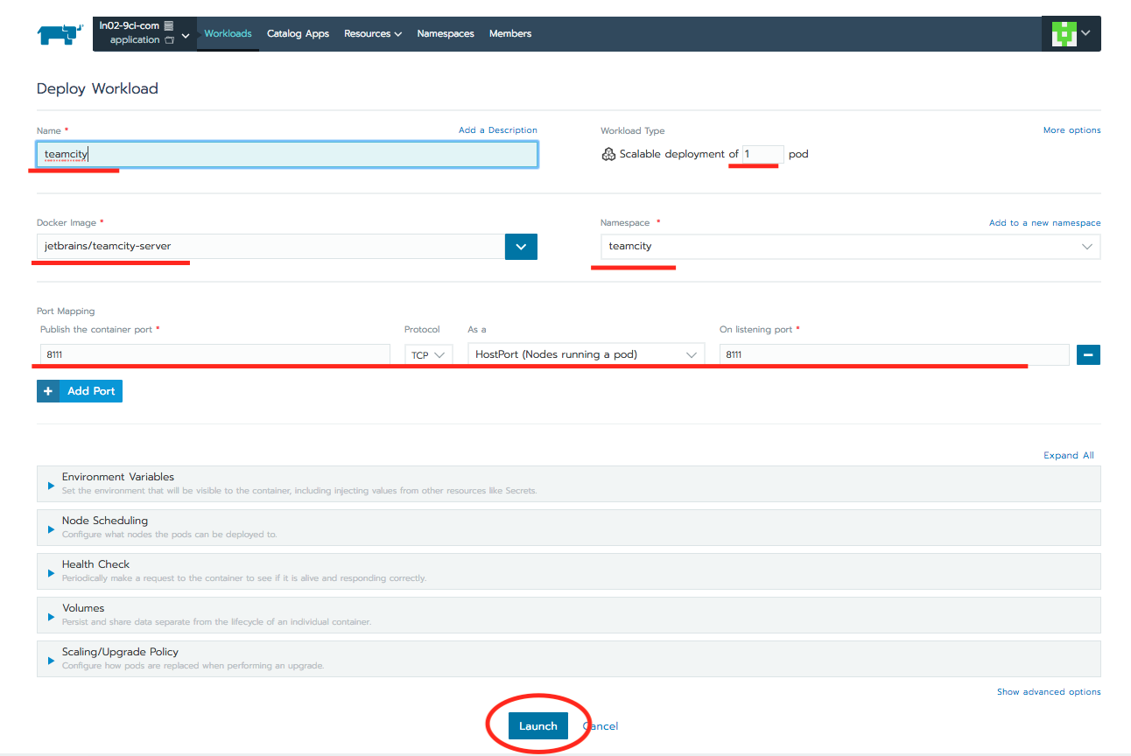

1. Then you can see the deployed Teamcity docker on workloads page:

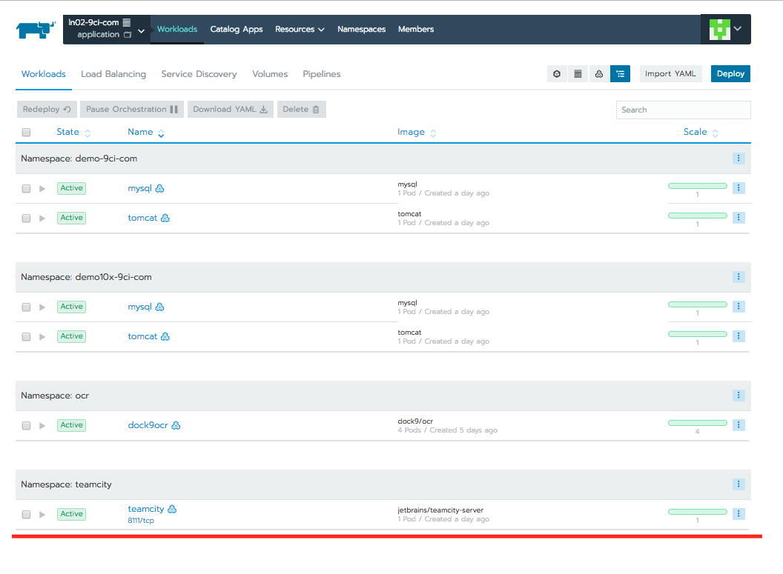

# **Delete Teamcity docker**

1. On workloads page, select Teamcity docker and click “Delete” submenu

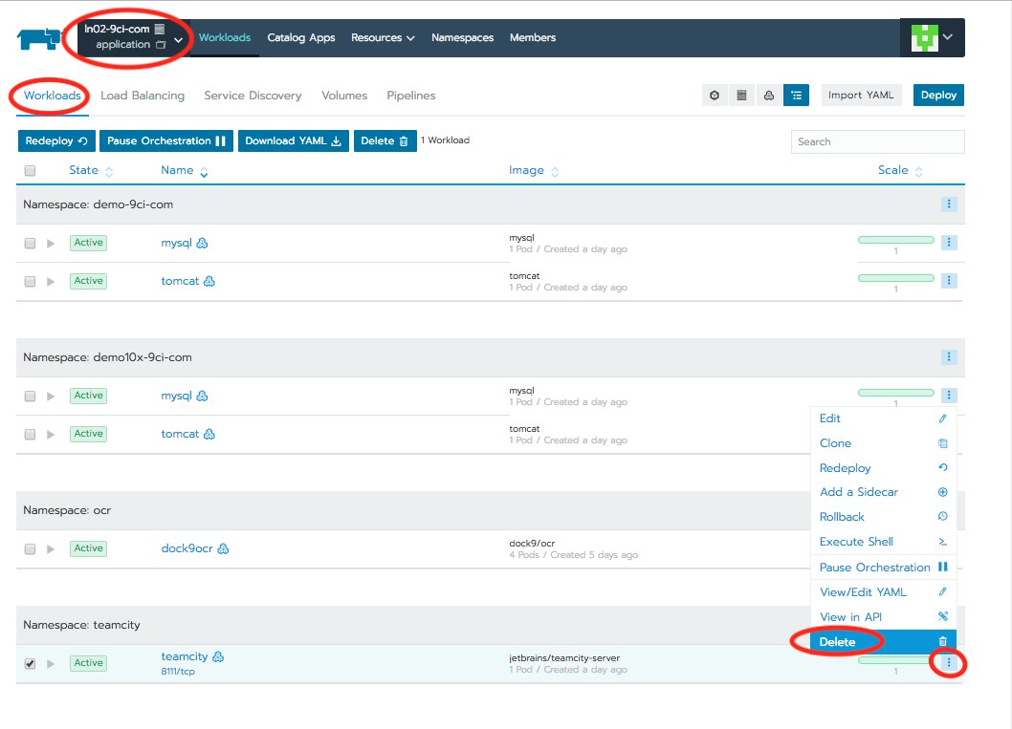

1. Click “Delete” button on confirm dialog

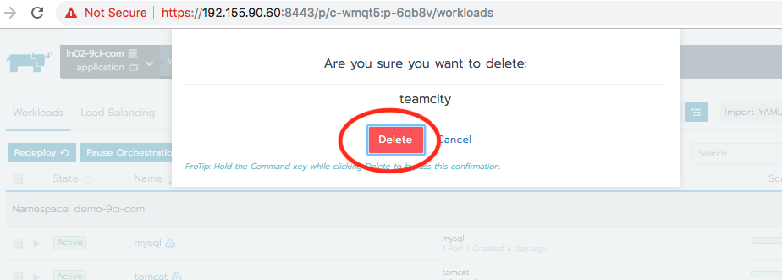

Then the Teamcity docker will be deleted from workloads.